**Project Name:** Android Based Remote Controlled Dimmer Circuit

**Project Summary:**

Smart home automation refers to all parts of a smart home, from lighting to security, from heat to energy. This system ensures that all these works that we have listed are done by an automatic system. Smart home automation allows you to automatically turn off all the lights even if you are not at home, and even automatically turns on the lights you predetermined when you are about to come home. In this study, an android-based remote-controlled dimmer circuit that can be used in smart home systems has been made. With this circuit, the brightness of a lamp can be adjusted at the desired level with the software we have installed on the Android phone. The remote control of the system was carried out with a bluetooth connection. The mobile interface design of the system was made with AppInventor. In addition, the electronic circuit of the system is realized as PCB.

**Material and Method**

The project consists of two parts, software, and hardware. In the software part, the mobile application of the system is carried out in the AppInventor environment. In the hardware part, the necessary electronic circuit is created. There is a microcontroller in the electronic circuit part, a Bluetooth module, and other electronic circuit elements to transfer the information from the user to the microcontroller. The printed circuit design of the circuit was carried out using the EasyEda interface.

**Elektronic Circuit Diagram**

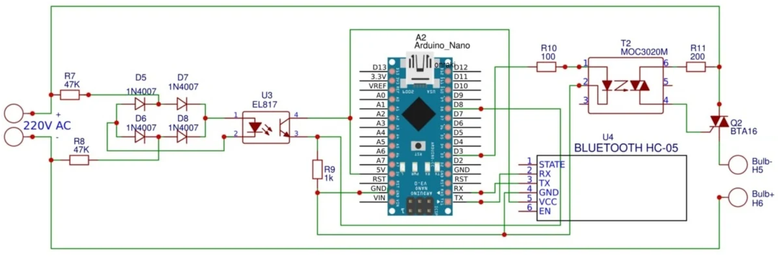

**Circuit PCB Layout :**

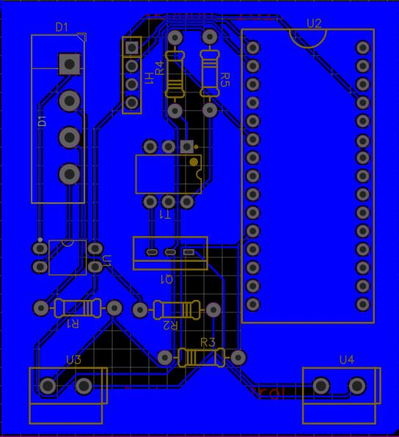

**Circuit 3D View:**

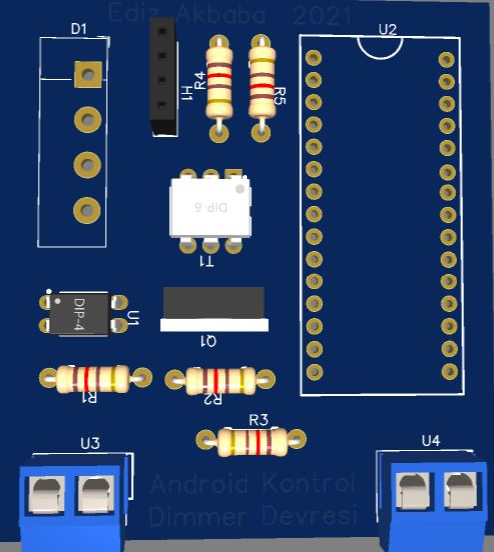

**Mobile App View**

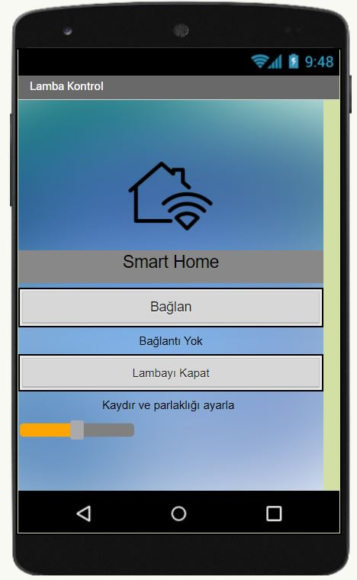

**Circuit conponents:**

• Printed circuit board

• Arduino Nano

• Bluetooth HC-05

• BTA16 triac

• EL817 optocoupler

• MOC3020 optocoupler

• Bridge Diode

• 47 K, 1K, 100 ohm, 200 ohm resistors

• Terminal

• Female Header